Start Putty
Command Prompt> mode (shows which com port the console cable is plugged into)
Command Prompt> putty (starts putty)
Change Connection Type to Serial and change the name to match the name found after typing mode
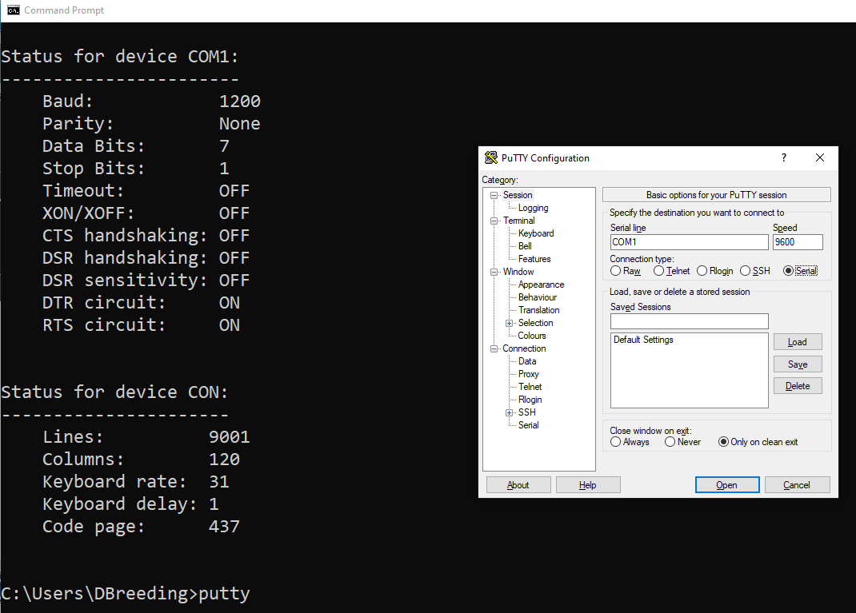

Router - Programming
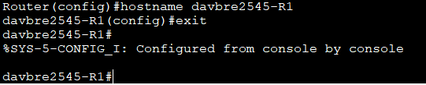
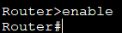

Router – Port Activation
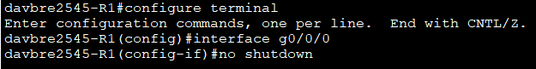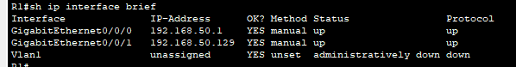

Router – IP Addressing
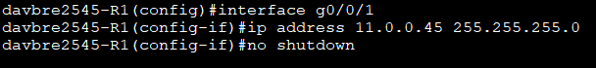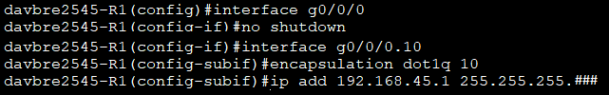

Router – Show Configuration
Router# show run
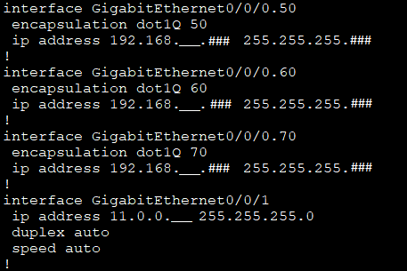

Router – Ping
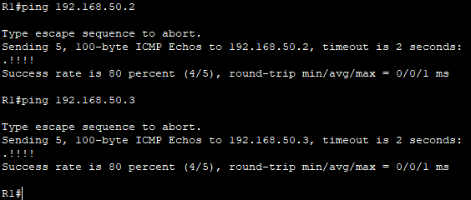

Router – DHCP Programming
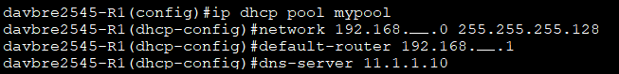

Router – Password Protect VTY (Virtual Teletype)
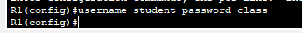
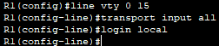

Router – Password Protect Auxiliary
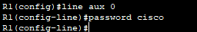

Router – Password Enable
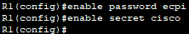
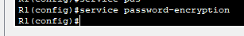

Router - Password Protect Console
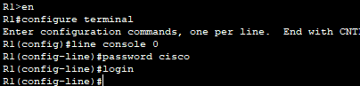

Router – RIPv2
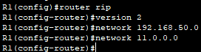

Router – OSPF

Router – Save Configuration
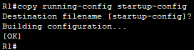

Router – Configuration Help
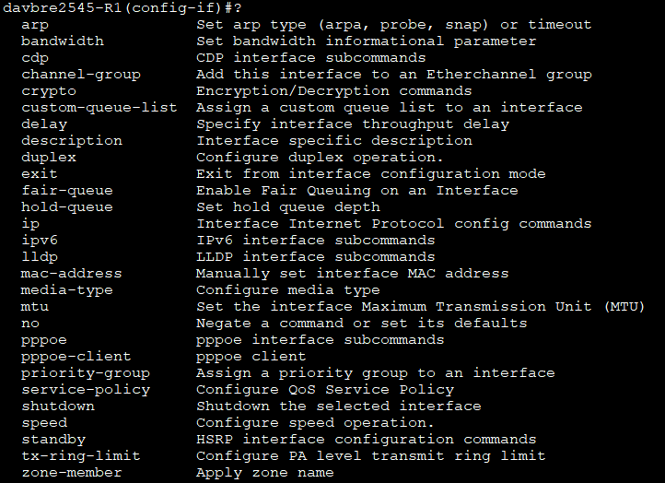

Router – IP Addressing Help
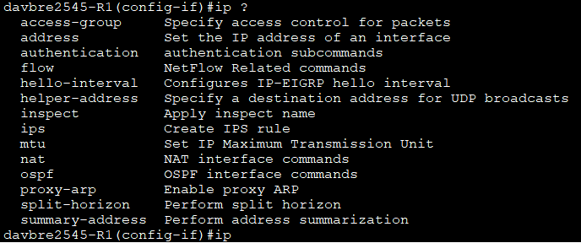

PC – IP Addressing
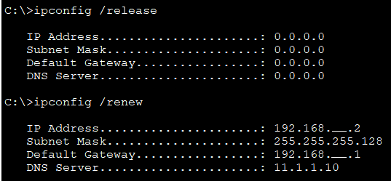

Switch – Programming
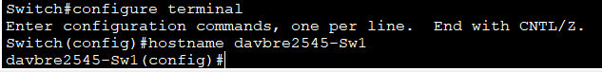
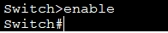

Switch – Allocate ports 1-23 to VLAN 10
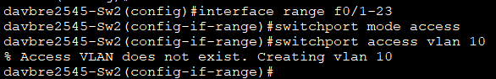

Switch – Program Trunk Port

Switch – Show Configuration
Sw1# show run
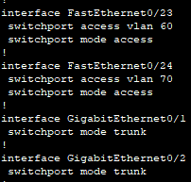

Switch – Recognizing VLANS
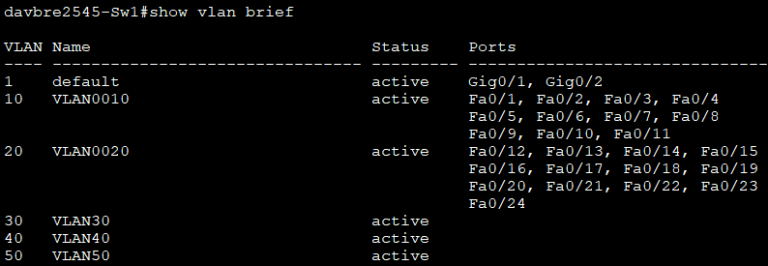
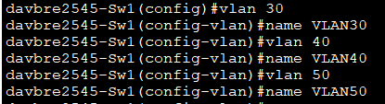

Switch – Port Security
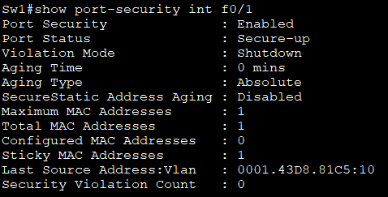
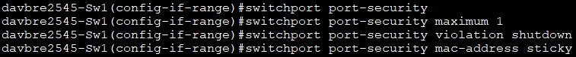
Interface range f0/1-23

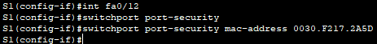

Switch – Program SPAN (Switch Port Analyzer)

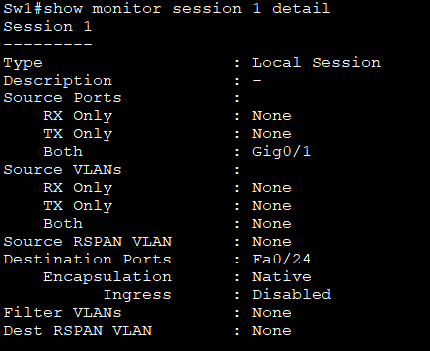

Internet – Programming
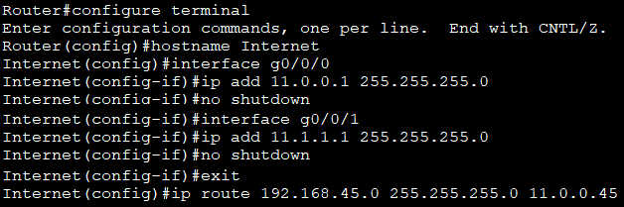
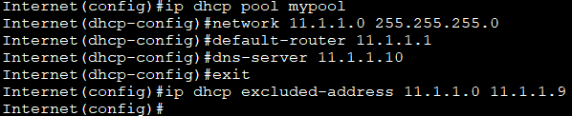
You will need to connect your router to the Internet router using a straight-through cable. Connect from the g0/0/1 port on your router to g0/0/0 port on the Internet router.
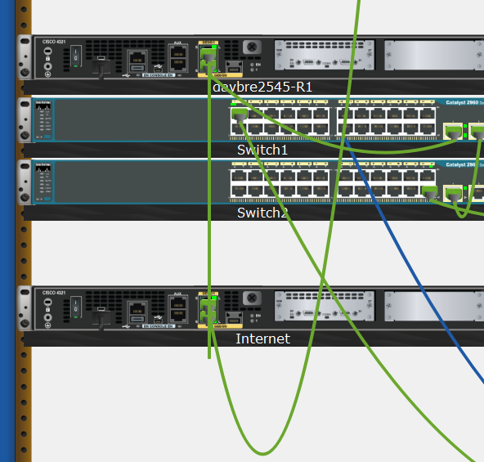

Internet – Static Routing
